
RAJALAKSHMI INSTITUTE OF TECHNOLOGY
(An Autonomous Institution, Affiliated to Anna University, Chennai)

DEPARTMENT OF ARTIFICIAL INTELLIGENCE AND DATA SCIENCE
ACADEMIC YEAR 2025 - 2026
SEMESTER III

OBJECT ORIENTED PROGRAMMING LABORATORY
MINI PROJECT REPORT

REGISTER NUMBER | 2117240070266
NAME | SAM MESHESK P
PROJECT TITLE | DIGITAL FILE LOCKER
DATE OF SUBMISSION
FACULTY IN-CHARGE | Mr.S.SELVAKUMARAN

Signature of Faculty In-charge

ABSTRACT:

The Digital File Locker is a secure Java-based desktop application designed to safely store, retrieve, and manage personal files. It employs Object-Oriented Programming (OOP) principles, file handling, and optional encryption to protect user files from unauthorized access.
Users can register, log in, upload files, retrieve them when needed, and delete stored content. All operations are internally secured using password hashing and basic encryption techniques. The project emphasizes modular software design, encapsulation, and I/O handling in Java. A menu-driven interface ensures simplicity, usability, and practicality for real-world use cases.

INTRODUCTION:
With data privacy becoming increasingly important, many users require secure offline tools to safeguard sensitive files. Traditional cloud storage systems depend on internet connectivity and raise concerns over data leakage.
This project introduces a Digital File Locker, a local offline tool enabling protected storage of confidential documents. The locker uses a password-based authentication mechanism, ensuring only authorized users can access stored content.
Key operations include:
- Secure login / registration
- File upload
- File retrieval / view
- File deletion
This application highlights efficient use of Java I/O, exception handling, encapsulation, and encryption.

SYSTEM DESIGN:

1. Architecture
The system follows a modular design pattern:

● User Authentication
Handles registration and login with hashed passwords.

● Locker Management
Performs file storing, retrieval, and deletion.

● Data Handling
Uses Java I/O for file-level operations.

● Encryption (optional)
Secures file content before saving and decrypts when retrieved.

2. Components
Component | Description
MainApp | Entry with menu control
User | Stores user details
AuthManager | Handles login & signup
Locker | Stores, retrieves & deletes files
Encryptor | Provides encryption

3. Data Flow
- User opens software
- Login / Signup
- Locker menu displayed
- File operation request
- System encrypts or decrypts file
- Action completed and confirmed

4. Technologies Used
- Programming Language: Java
- File Handling: Java I/O
- Security: MessageDigest, Base64
- IDE: IntelliJ / Eclipse / NetBeans
- Version Control: GitHub (optional)

IMPLEMENTATION:

1. Technology Stack
- Java
- Java I/O
- SHA-256 hashing
- Base64 encoding

2. Core Functionalities

✔ User Registration
Store hashed password in credentials file.

✔ Login Authentication
Matches stored hash with user input.

✔ File Storage
Encrypts file content and saves locally.

✔ File Retrieve
Decrypts and displays file content.

✔ Delete File
Secure deletion from locker.

CODE :

public class Main {
// Directory constants from the original console app
public static final String DATA_DIR = "locker_data";
public static final String FILES_DIR = DATA_DIR + "/files";
public static final String DOWNLOADS_DIR = "locker_downloads";
public static void main(String[] args) {
// 1. Initialize directories (same as before)
try {
Files.createDirectories(Paths.get(DATA_DIR));
Files.createDirectories(Paths.get(FILES_DIR));
Files.createDirectories(Paths.get(DOWNLOADS_DIR));
} catch (IOException e) {
System.err.println("Fatal Error: Could not create necessary directories. Exiting.");
e.printStackTrace();
return;
}
// 2. Launch the GUI on the Event Dispatch Thread (EDT)
// This is the standard, thread-safe way to start a Swing application.
SwingUtilities.invokeLater(() -> {
LoginWindow loginWindow = new LoginWindow();
loginWindow.setVisible(true);
});
}
}

OUTPUT:

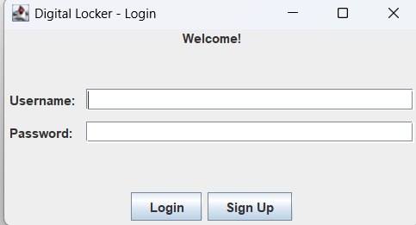

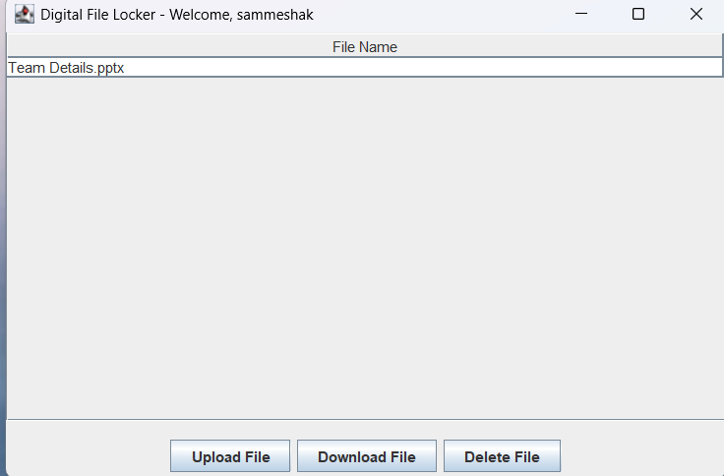

RESULT :

The Digital File Locker successfully secures file data through password-based access and optional encryption. It highlights:
✔ Strong security using SHA-256 hashing
✔ Encapsulation & modular OOP structure
✔ Efficient file I/O operations
✔ Easy extension for advanced crypto & GUI

CONCLUSION:

The Digital File Locker project demonstrates the practical utilization of Object-Oriented Programming concepts, file handling techniques, and security modules in Java. It ensures safe offline storage of sensitive information, protecting user data from unauthorized access. The system can be improved further using advanced cryptography, multi-user storage, or integration with GUI.

Git Hub Link of the project and report | https://github.com/sammeshak33-hash/OOPS-MINI_PROJECT/tree/main/src

REFERENCES:

• Oracle Java Docs – File I/O
• Oracle Java Docs – Security APIs
• TutorialsPoint – OOP in Java
• GeeksforGeeks – SHA-256 Hashing
• W3Schools – Java Basics

